Site Recording Card
Cambridgeshire and Peterborough County Wildlife Site Re-survey

Site Name: St Denis’ Churchyard

Parish: Hatley | Grid ref. TL285505
Date: 25/06/12 | Surveyor(s): Siân Williams
Time spent on site: 2 hours | Weather: Sunny
Management condition:
Favourable
Stable

Notes:
The site is being cut several times a year, with arisings removed. Rob Mungovan, South Cambs Ecology Officer, has provided advice on timing and locations of cuts. The management group has also been pulling nettles around the base of the church and the area of nettles has noticeably decreased since the time of the last survey. The current management is maintaining the site in favourable condition, and should be continued.

Status of CWS features: (state current qualifying criteria)
Intact. The site still qualifies because it supports frequent numbers of eight or more neutral grassland indicator species.

Notes/suggested boundary revisions:
The site supports a total of 19 neutral grassland indicator species, 11 of which are found in at least frequent numbers, which is a very good total for a small site.

Site Description:
The site is a churchyard/burial ground and local nature reserve surrounding the disused church of St Denis in East Hatley. It contains species-rich neutral grassland, with the northern section being particularly high quality, unimproved grassland. (see map)

The northern section supports a variety of grassland species, including abundant rough hawkbit (see photo below), black knapweed, yellow oat-grass, lady’s bedstraw, hoary plantain and salad burnet, and bee orchid.

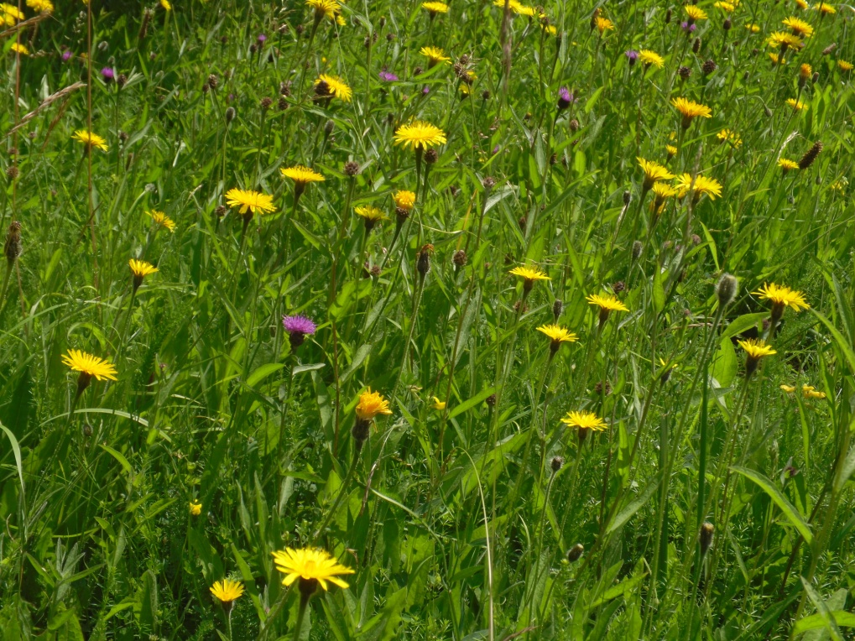

This northern area also contains the woodland-associated species oxlip and bugle, and therefore is not cut at the beginning of the year, to allow these plants time to flower and set seed. The grassland species, and particularly the rough hawkbit, are also thriving under this management.

The remainder of the churchyard is not as species rich, and has higher abundance of rough grasses such as false oat-grass and common couch and negative indicators including nettles and cleavers. However, it still contains a good range of positive indicator species such as meadow vetchling, black knapweed and salad burnet.
More frequent mowing of this southern section of the site, with arisings removed, should be continued to help reduce nutrient levels and prevent the negative indicators from spreading.

A few trees have been planted within the grassland area, and there are burial plots and headstones, a few of which have the areas directly adjacent to them managed and/or planted.

The site is surrounded by hedges and trees, including species such as elm, blackthorn, hawthorn and bramble, which are spreading into the grassland to some degree along the western edge. Under the trees is a band of typical hedgebank vegetation, such as dog’s mercury, wood false-brome, and hedge woundwort.

A mown path is maintained from the entrance the site and around the church, and arisings from this and other management are left in discrete piles near the site edges.

There is a small band of rank vegetation, dominated by nettles, around the base of the church building.

Other species observed during the survey included chiffchaff, chaffinch, blackbird, large skipper and meadow brown butterflies, yellow shell moth, and a meadow grasshopper calling. There was also a young raptor calling from the boundary of the site, possibly a fledgling kestrel or sparrowhawk.

